Repaso
Formularios
Agenda
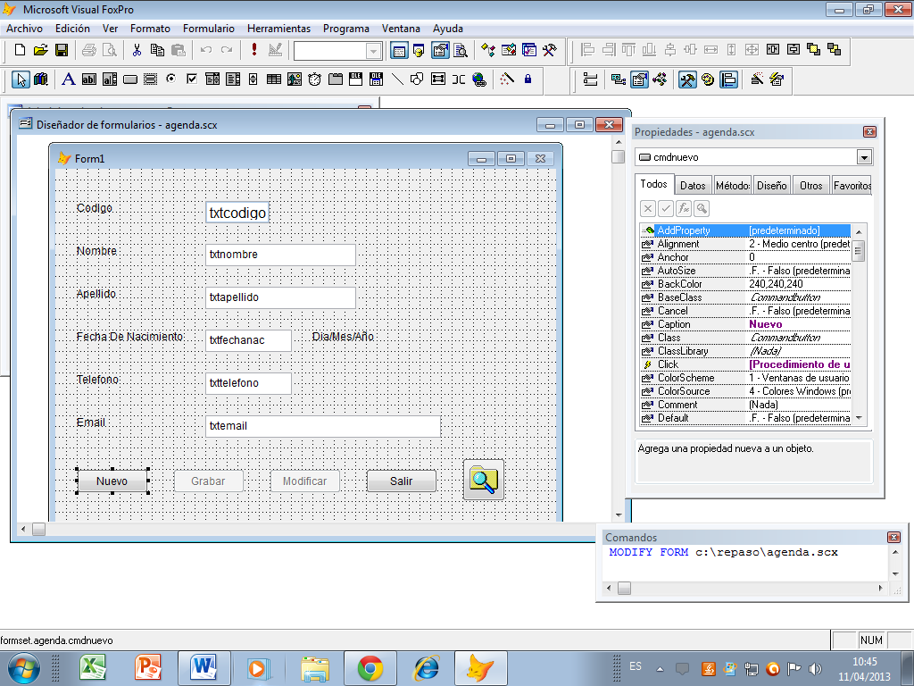
Nuevo
ThisForm.txtcodigo.value = 0
ThisForm.txtnombre.value = ""
ThisForm.txtapellido.value = ""
ThisForm.txtfechanac.value = ""
ThisForm.txttelefono.value = ""
ThisForm.txtemail.value = ""
USE codigo
ultimocod = numero
USE
ultimocod = ultimocod+1
thisform.txtcodigo.value = ultimocod
thisform.cmdgrabar.enabled= .T.
thisform.cmdmodificar.Enabled= .T.
this.Enabled= .F.

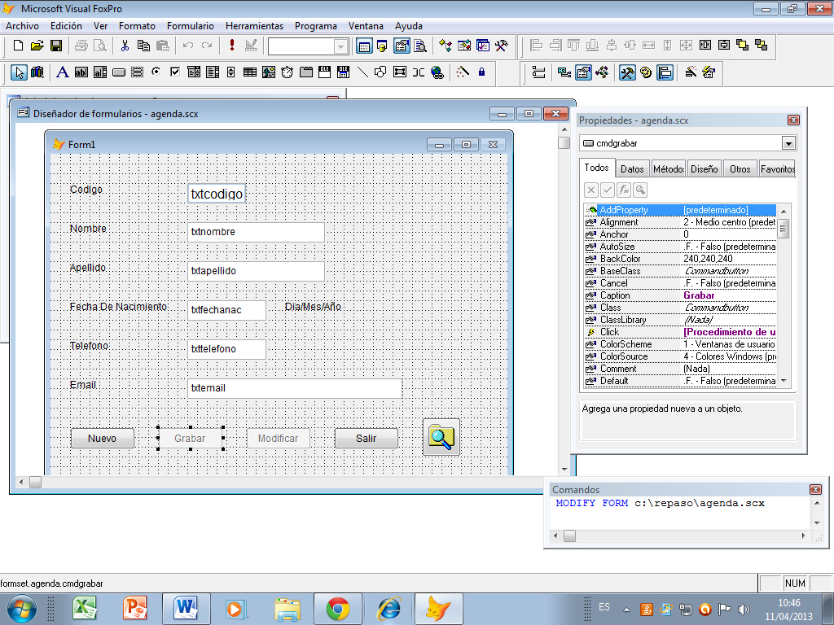
Grabar
USE agenda
APPEND BLANK
replace codigo WITH thisform.txtcodigo.Value
replace nombre WITH thisform.txtnombre.Value
replace apellido WITH thisform.txtapellido.Value
cNacimiento=thisform.txtfechanac.value
replace fechanac WITH CTOD(cNacimiento)
replace telefono WITH thisform.txttelefono.Value
replace email WITH thisform.txtemail.Value
USE
*
USE codigo
replace numero with ultimocod
USE
MESSAGEBOX("registro guardado", 64, "agenda.dbf")
thisform.cmdgrabar.enabled= .F.
thisform.cmdmodificar.Enabled= .F.
thisform.cmdnuevo.Enabled= .T.

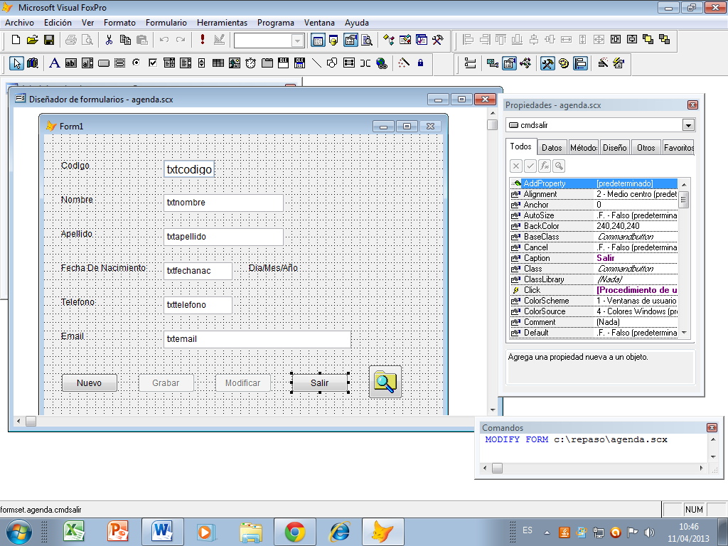

Salir

thisformset.release

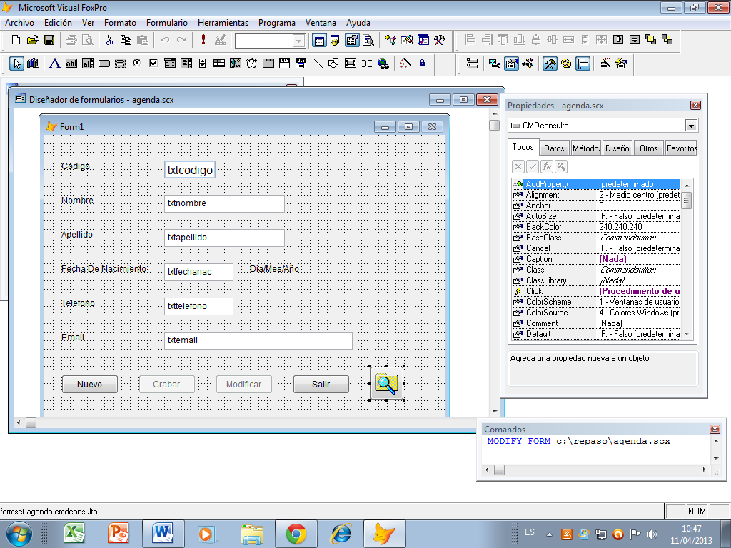

Busqueda
ThisFormset.form2.visible= .T.

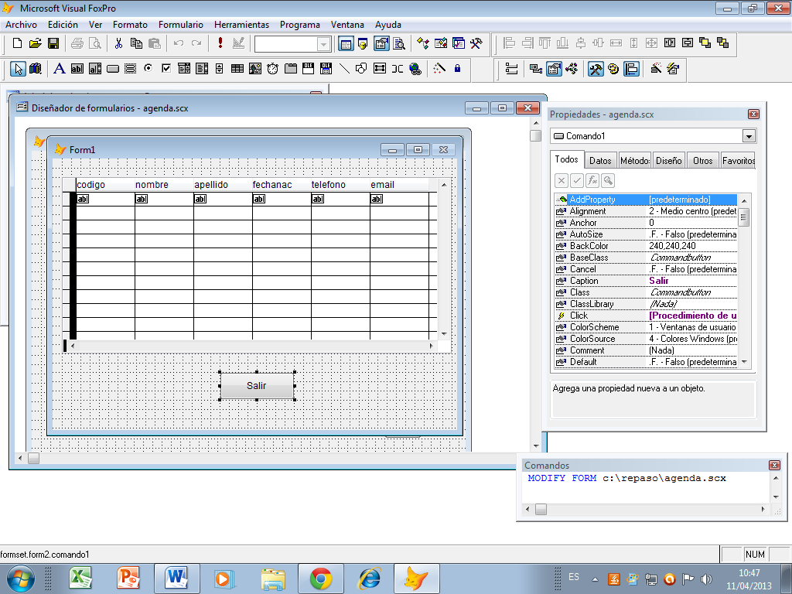
Salir
thisformset.form2.Visible= .F.
thisformset.refresh

